TEM Mini Manual

**Synchronization of Receiver (Rx) and Transmitter (Tx)**

Turn ON (crystal power) XMT and GDP 1 hour before actual data collection in the field.

Set XMT to:

Frequency: 1 HZ

Duty Cycle: 100%

Press CONTINUE on GDP

Connect sync cables between XMT and GDP:

Connect CAL out of XMT to GDP CH2

*RED……………………………...RED*

*BLACK………………………….BLACK*

Connect CAL output of GDP to GDP CH1

GDP GDP

CAL+ Red

CAL- Black

Set meter switches in Lid of GDP to monitor channels 1 and 2.

Press CONTINUE, CONTINUE

Adjust crystal using SELECT UP/SELECT DOWN for coarse and UP/DOWN ARROW for medium and PREV/NEXT FIELD for fine adjustment until phase meter needle stops completely.

Then Press RESET on XMT (both meters should deflect to the RIGHT).

Press CONTINUE to acquire phase data

NB: Needle should rest near the middle of the meter.

Press RESET to synchronize

Press CONTINUE.

GDP automatically measures phase differences ~=0.0 mr

Repeat above to recheck synchronization`=0.0mr

Disconnect sync cables and repeat phase measurement `=0.0 mr

View data (DATA **F7**) to Plot data **F5**

***Data Collection @ Transmitter point***

XMT connect to Transmitter (TX) which is also connected to external batteries in SERIES.

Set XMT to:

Duty cycle: 50%

Frequency: 2, 4, 8, 16 HZ etc

Phase

Manual

Connect I/O XMT to Ext.Input of Transmitter

Connect transmitter Main Power to batteries in Series + to - and –to +.

Connect the loop to the transmitter (Clockwise loop goes to the + end of the transmitter and –ve to the anticlockwise end of the wire loop)

1. ON/OFF (back) to turn it ON
2. ON (second power): Polarity blinking to display and check
   1. Voltage
   2. Current
   3. Decay
   4. Temperature

To begin collecting data:

Transmit by simultaneously pressing RESET & TRANSMIT buttons on TX to send current in the loop.

XMT

+ -

TX o >….0 _

- +

- +

- +

+ -

+ -

+ -

**+**

Loop **-**

Batteries (series connection)

Figure X1: Connection at Transmitter point during data collection

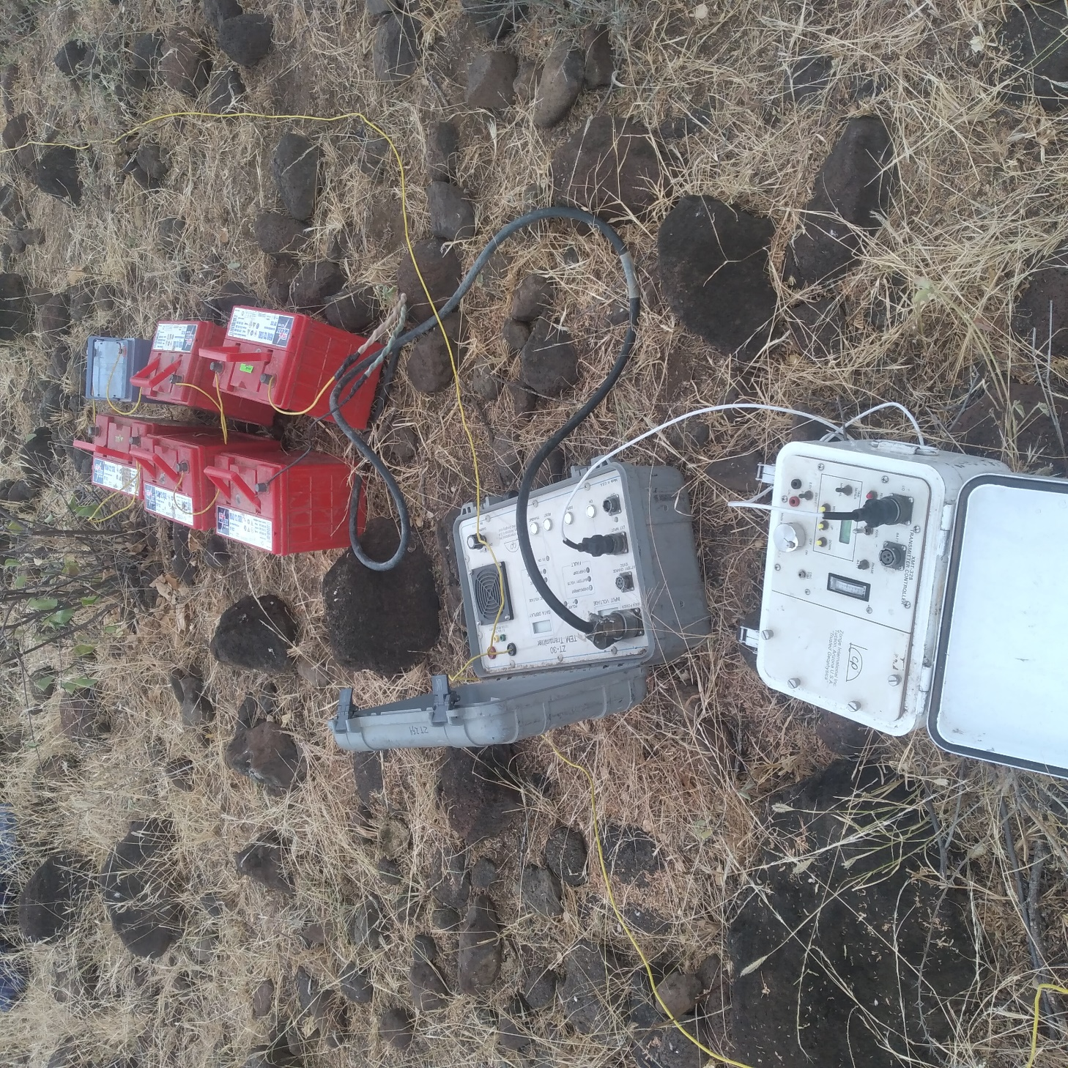

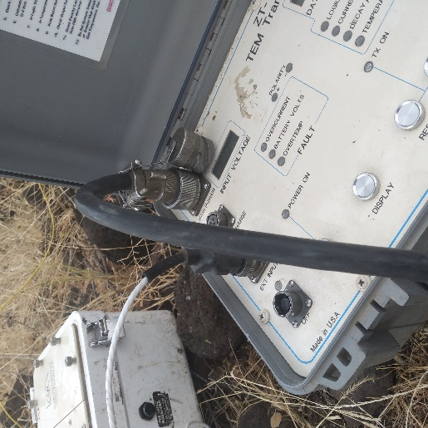 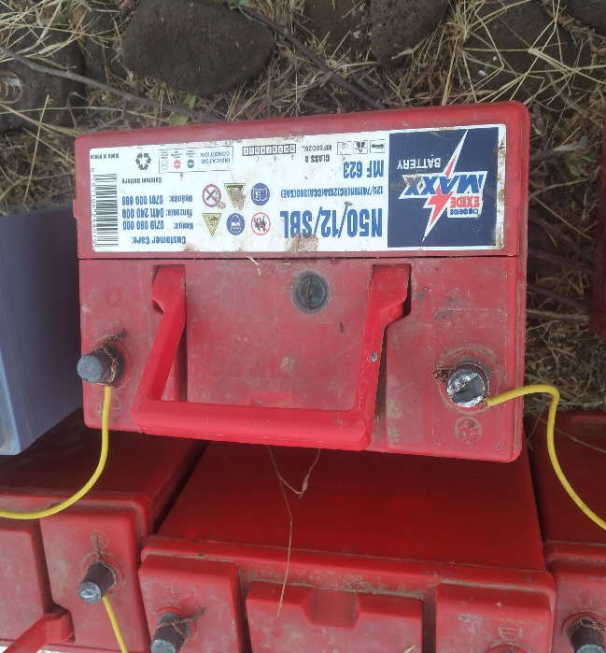

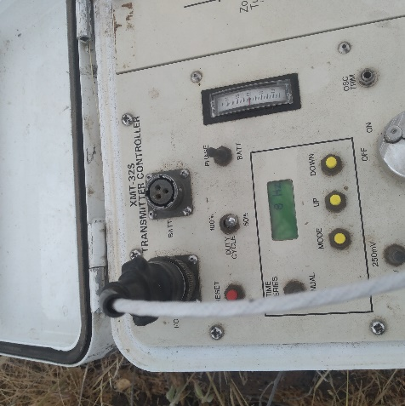

Figure X2: Connection at Transmitter point during data collection (Pictorial)

**Data collection at the Receiver point connection (in the middle of the loop)**

COM

CH1

+

**-**

_

Receiver coil

Receiver

GDP

Figure XX: Data collection Setup at the receiver

Figure Xy: Data collection Setup at the receiver

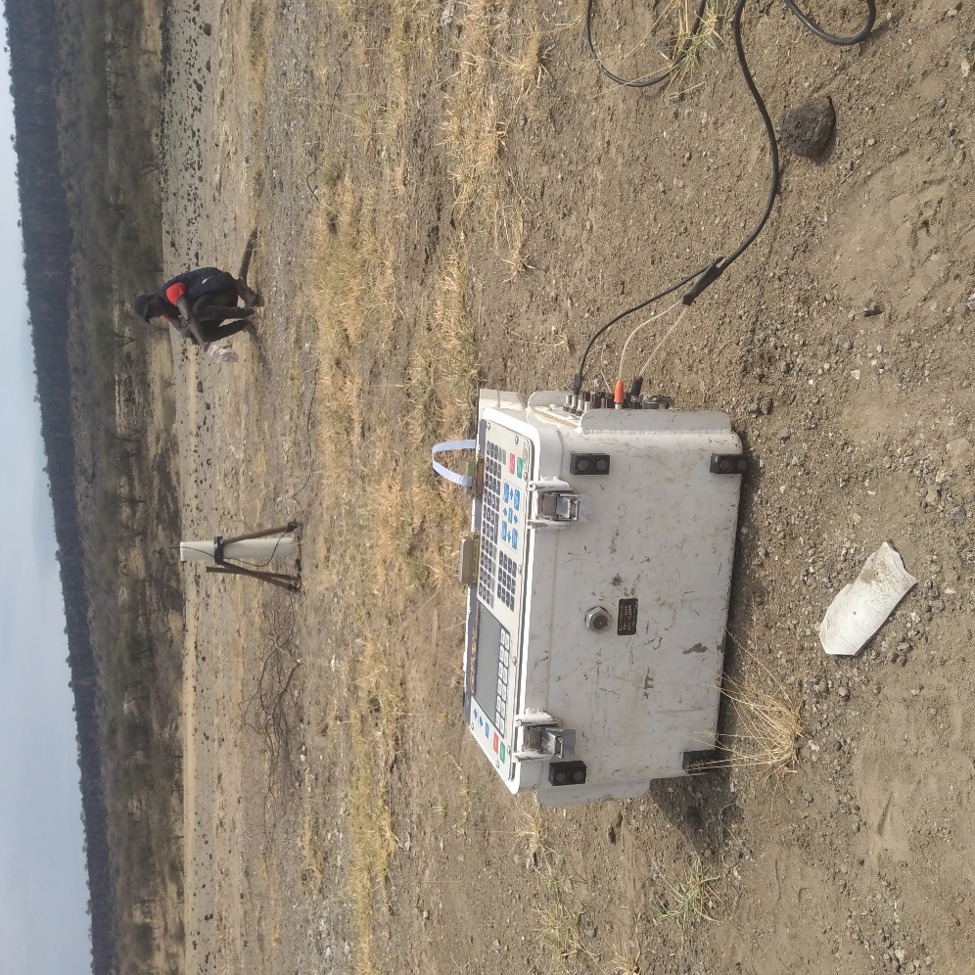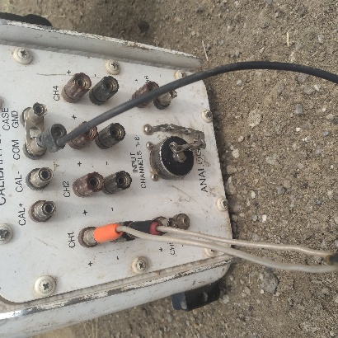

**TEM data Download**

To be completed…….

**TEM data processing**

Downloaded data in *.TXT* format is taken through the following procedure to ultimately process it into *.AVG* a format recognized by the interpretation software such as WinGlinK.

Sample location named: chtem10.txt will be process as follow:

Convert DP002.txt into DP002.AVG

Open window Xp

DATPRO folder with .txt file to be converted and support files.

Get into the path where.txt files are saved e.g

C:\Document & settings\Noor\desktop\Datpro> Edit (_space) DP002.txt ENTER (Blue screen appears)

Ensure data is OK with no errors if error exist correct before proceeding.

File>save as>edit file name to the current sounding and change .TXT to .RAW >OK > EXIT

DP002.RAW created

C:\Document & settings\Noor\desktop\Datpro>WAM.BAT >ENTER (Blue screen appears) Edit the file name to the current sounding without editing extensions

File > Save >EXIT

C:\Document & settings\Noor\desktop\Datpro>MURA.BAT >ENTER to view the plot.

DP002.AVG has been created

**Procedure for processing 16bit zonge GDP only**

Note that this procedure is done on windows xp only

1. Download data

Copy and paste FLDDATA.CAC(16 bit Zonge GDP) data file as downloaded from zonge GDP into a location of your choice.

Make sure CACCNVRT software also appears in the same location

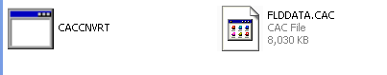

2. run CACCNVRT

Go into command prompt and run CACCNVRT FLDDATA.CAC to convert CAC file into readable data file

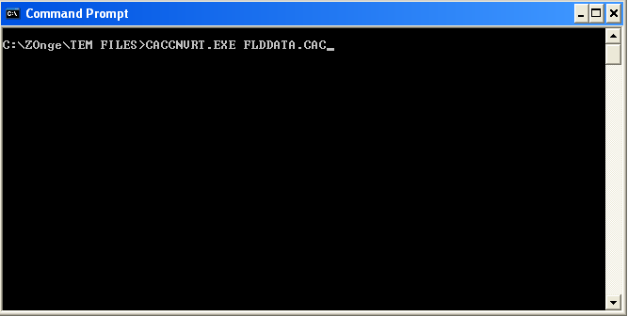

The output of the above command appears as shown below

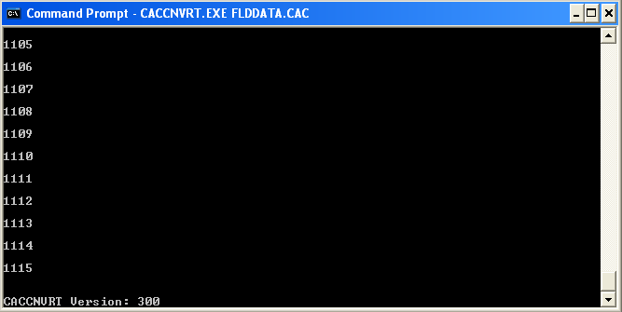

Press return(Enter on the keyboard) to exit the screen.Normal cmd screen appears as shown below

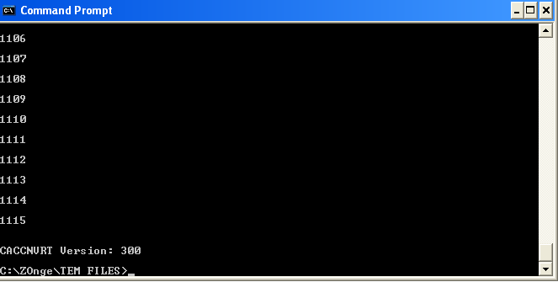

2. Datpro

Navigate the command prompt to where datpro is located

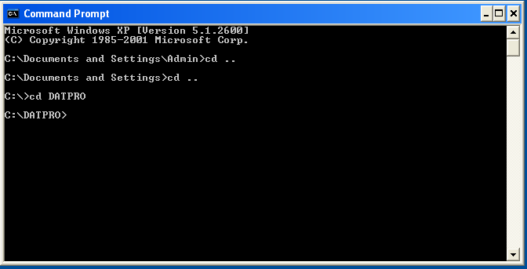

edit the station text file and convert to .raw

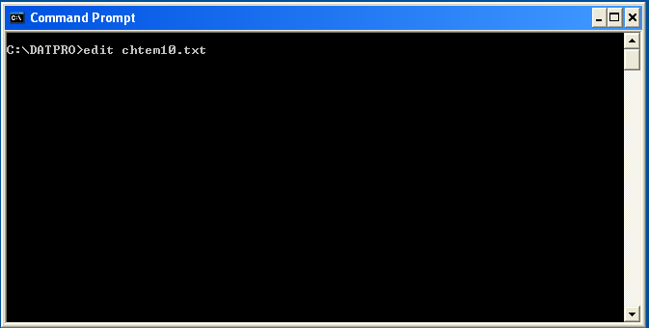

this screen helps know if the TX loop was inverterted. If the dacay (Mag column) appears with negative then this means the loop connection onto the TX was inverted

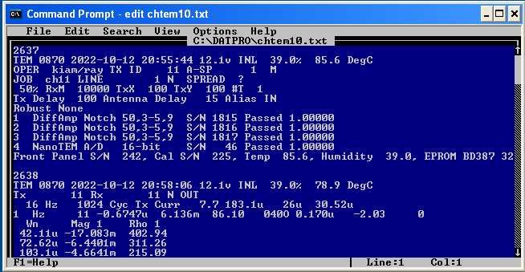

to rectify this invertion put a negative sign before Hz(-Hz)

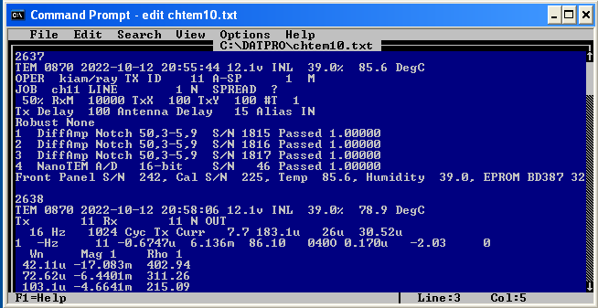

save as raw

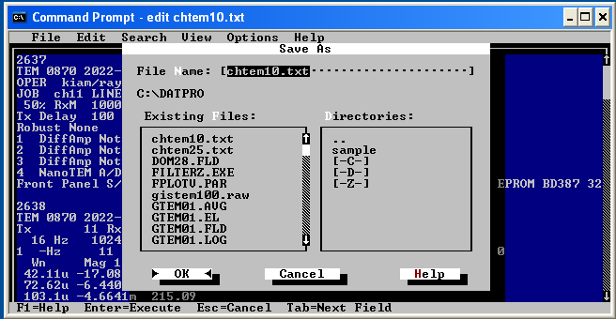

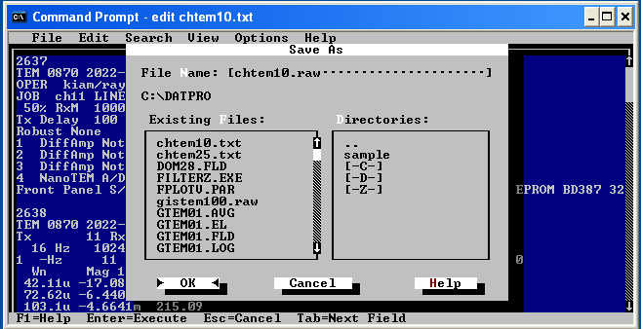

save

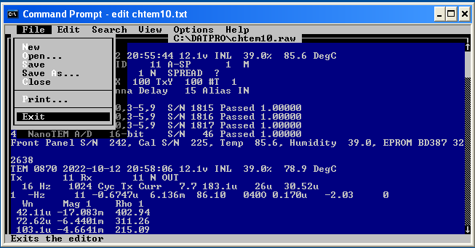

run wam.bat to set path for shred

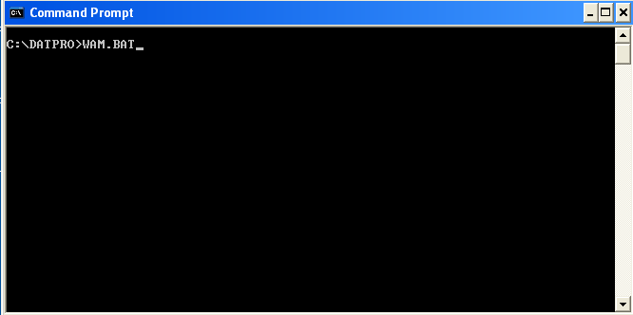

the screen below appears

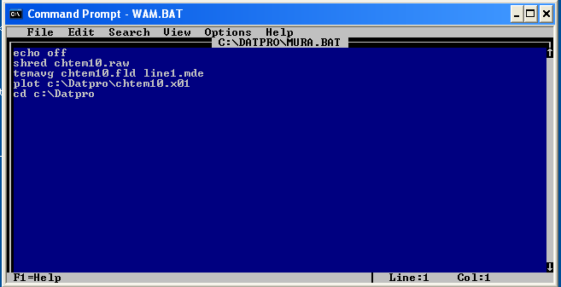

save

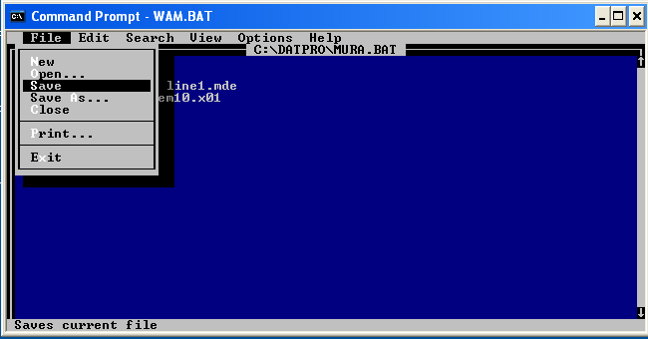exit

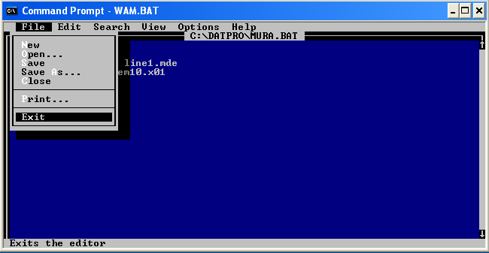

run mura.bat for ultimate conversion to avg

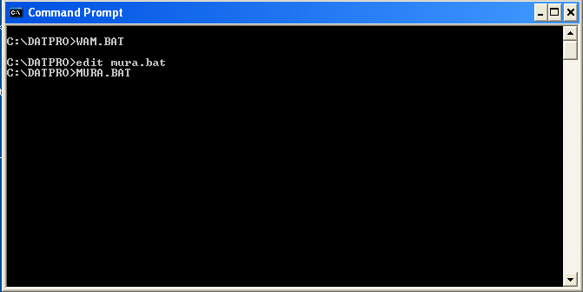check in your directory the following files will appear

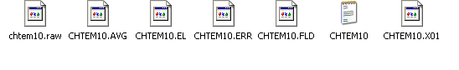

File appearance of txt file

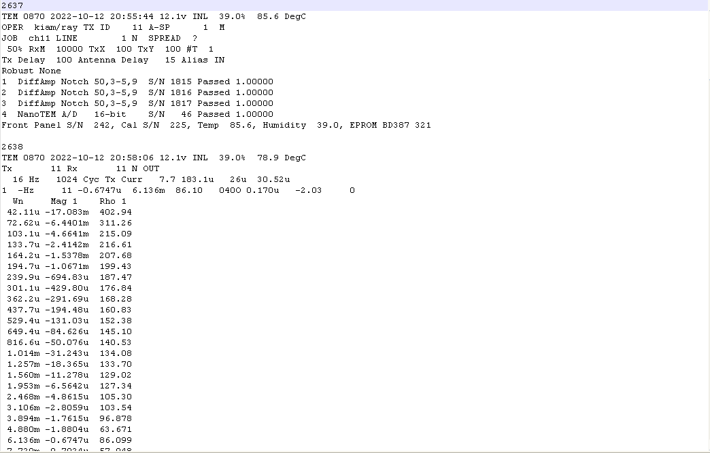file File appearance of avg file

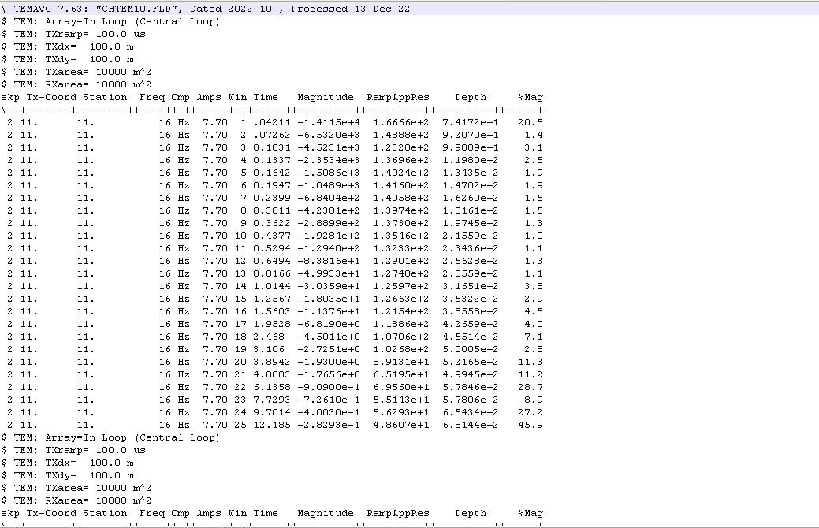

**Procedure for processing both 16bit/ 24bit zonge GDP**

This procedure processes both *.raw data for 16bit zonge GDP and *.CAC for 24bit Zonge GDP

Download the the *.CAC file from GDP and save the data in location of choice. Proper arrangement of files is important to allow easy access.

1. Below is the image of files that are significant during zonge data processing

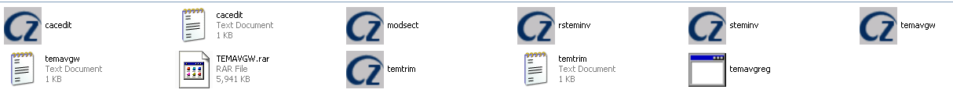2.Insert temavgw dongle and check if its registered

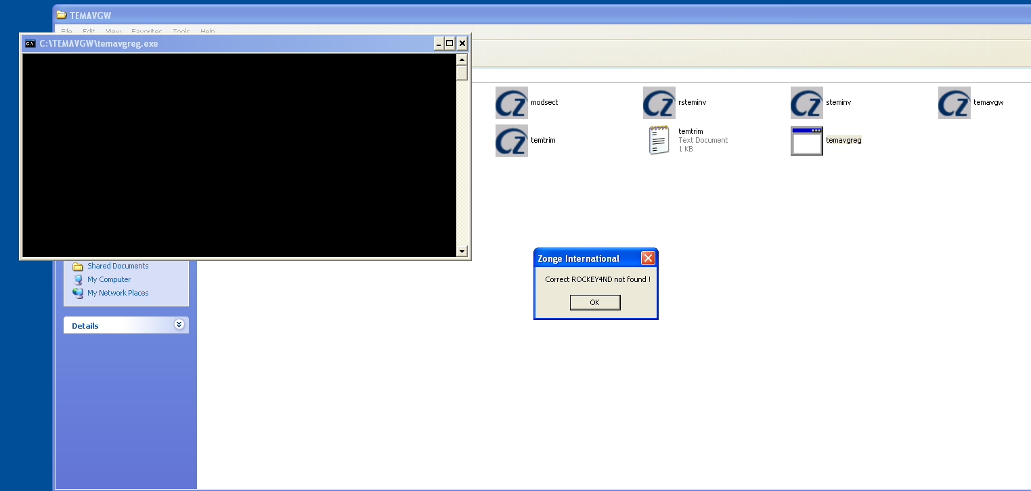

3. If not registered as shown above then , go ahead and registered. Check the licenses as shown below and pick one that has serial number corresponding to your dongle



4.copy the license into location with temavgw sofware, in this case temavgreg_9124 and rename to temavgreg

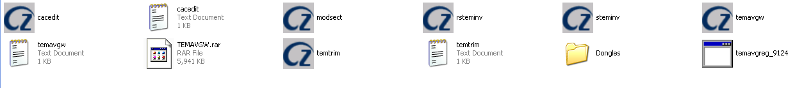5. Open temavgw software if no error appears as the case before then the license is working and you should proceed with processing

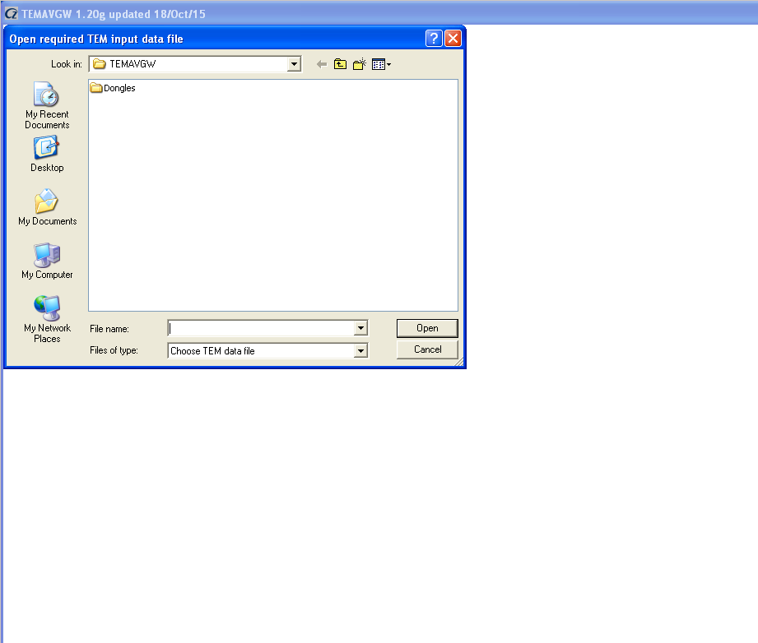

6. Open data (*.raw or *.CAC) of your choice

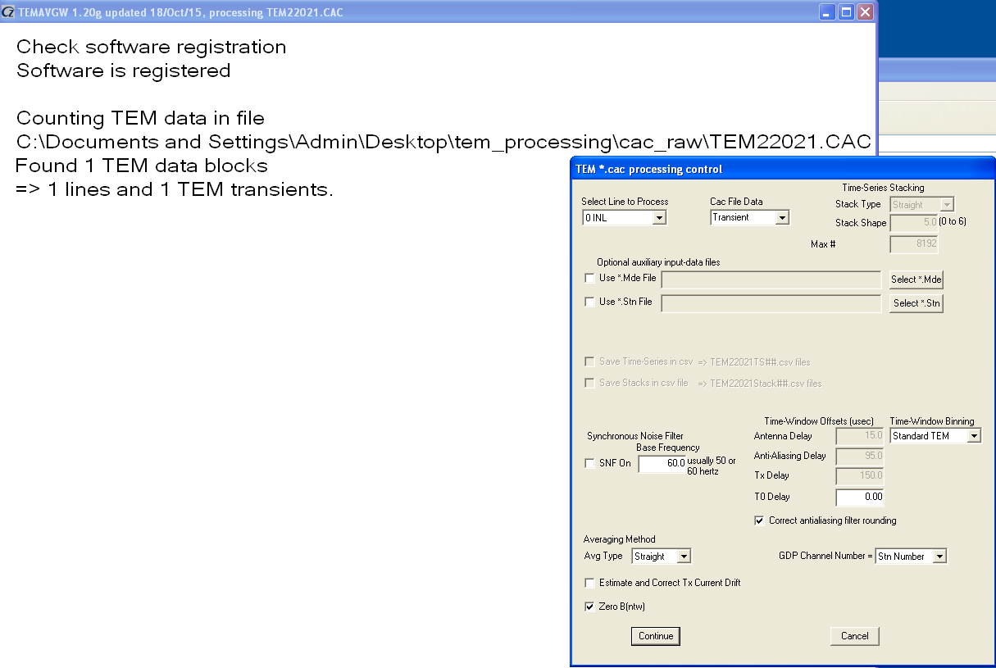

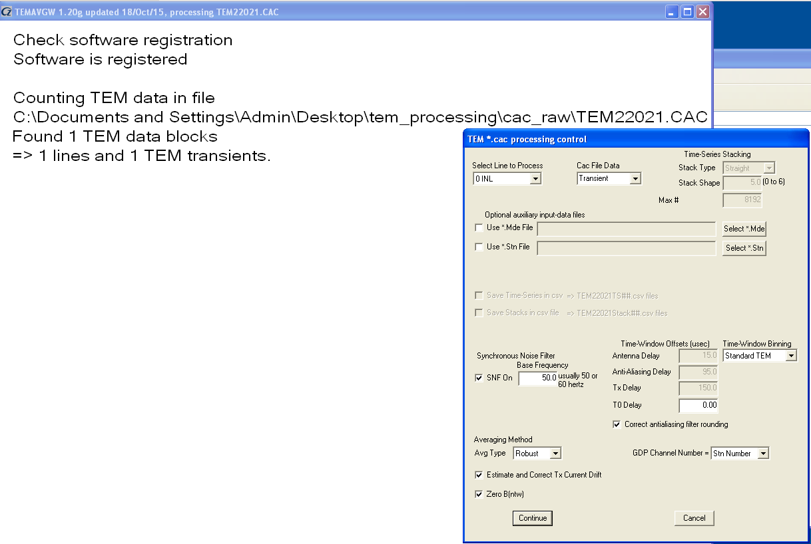7.

8.

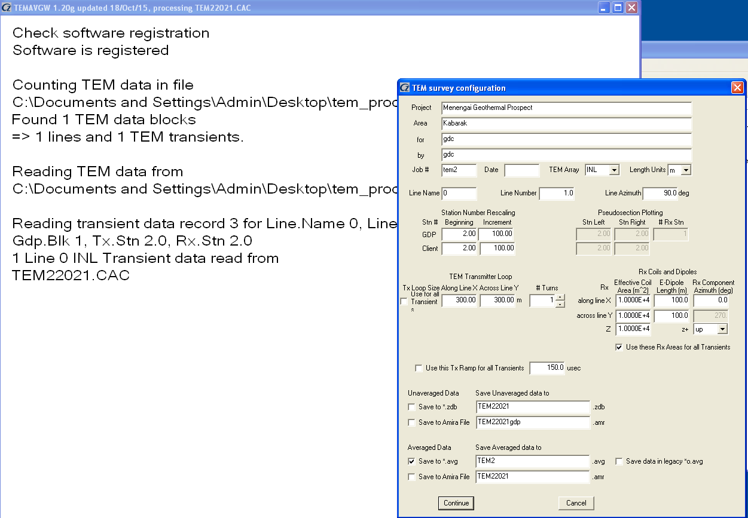

9. Data appears inverted

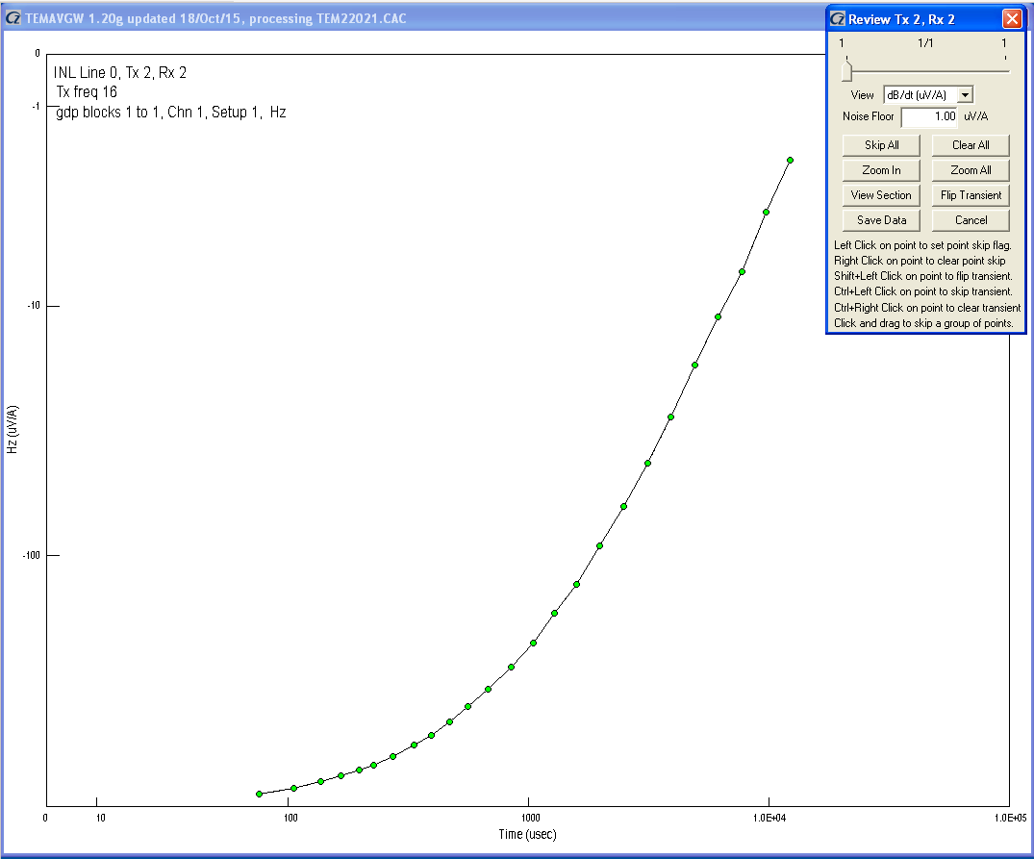

10. Apply flip transient

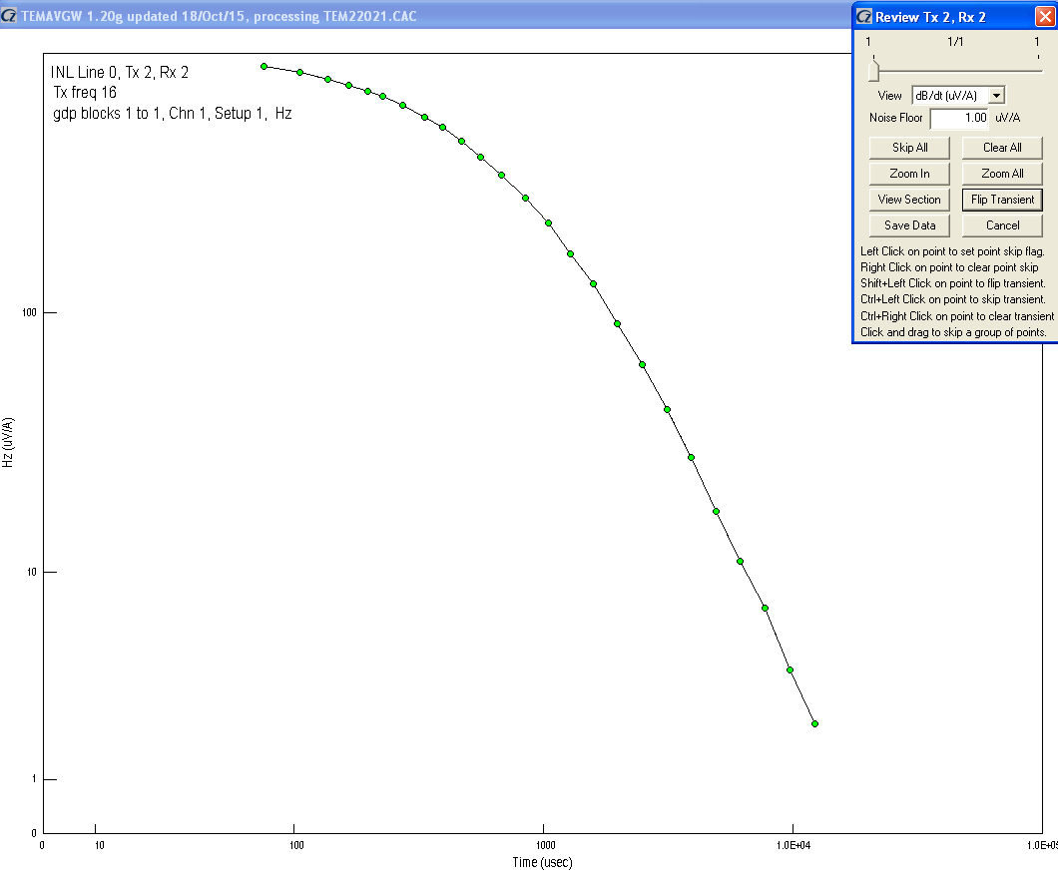

11. Fill required details

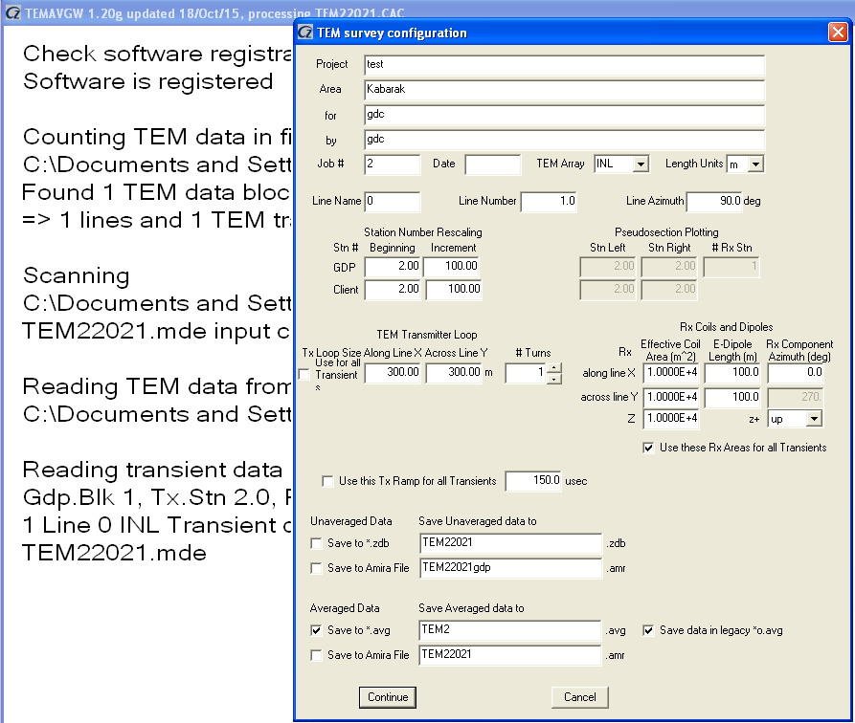

12. The following files will appear once. Two avg files appear. For winglink use TEM2o.avg which is the legacy format.

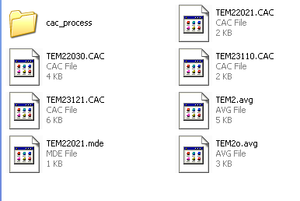

13.

File appearances

a. *.avg

this file can be used directly with STEIMNV software

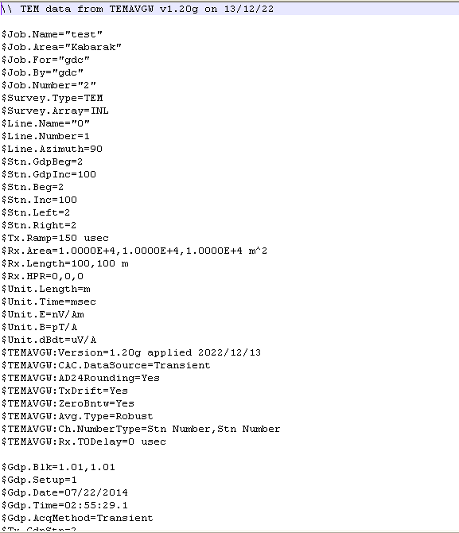

b. legacy *.avg

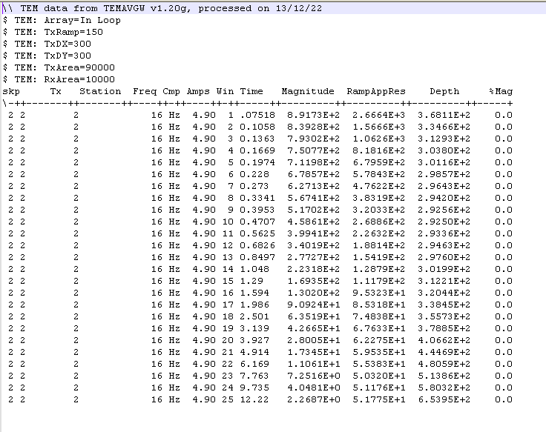

Note: the legacy avg file may not load into winglink due to deficiency of proper spacing.Manually editing of spacing is necessary. A script can also be used to align the columns

13. To save the data into USF format then open the temtrim software and open .avg file then save as USF. Note that to save the USF file you must have created a station location file which contains station name, longitude and latitiude.

………...to be continued